**Name: ________________________ Session: _________**

**Advanced Programming in Java**

**Lab Exercise 1.19.2023**

1. Write a program that reads the file “babynames.txt” and reports the most popular boy and girl name.
2. For faster sorting of letters, the USPS encourages companies that send large volumes of mail to use a bar code denoting the zip code.

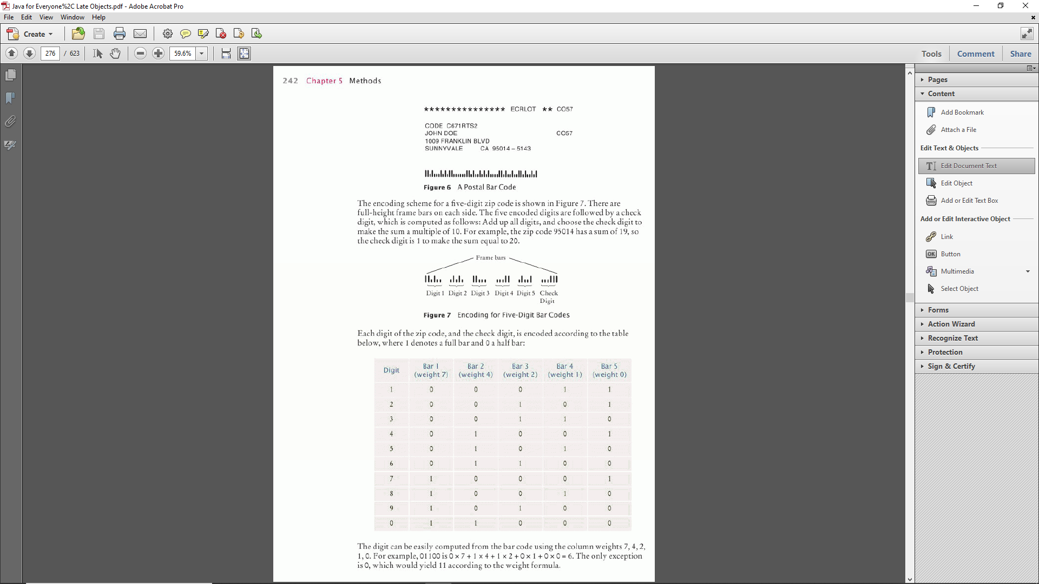

The encoding scheme for a five digit zip code as shown below. There are full height frame bars on each side. The five encoded digits are followed by a check digit which is computed as follows: Add up all of the digits and choose the check digit to make the sum a multiple of 10. For example, the zip code 95014 has a sum of 19, so the check digit is 1.

Each digit of the zip code, and the check digit, is encoded according to the table below where | denotes a full bar and : a half bar.

|  |  |
| --- | --- |
| 1 | :::|| |
| 2 | ::|:| |
| 3 | ::||: |
| 4 | :||:: |
| 5 | :|:|: |
| 6 | :||:: |
| 7 | |:::| |
| 8 | |::|: |
| 9 | |:|:: |
| 0 | ||::: |

Write a program that asks the user for a zip code (5 digit) and prints the bar code. For example 95014 becomes:

||:|:::|:|:||::::::||:|::|:::|||